**Full Stack Development with MERN**

**Database Design and Development Report**

|  |  |
| --- | --- |
| Date | 20-07-2024 |
| Team ID | SWTID1720019632 |
| Project Name | House Rent App Using Mern |
| Maximum Marks |  |

**Project Title**: House Rent App Using Mern

**Date**: 20-07-2024

**Prepared by**: Hiruthick SM

**Objective**

The objective of this report is to outline the database design and implementation details for the House Rent App Using Mern project, including schema design and database management system (DBMS) integration.

**Technologies Used**

* **Database Management System (DBMS):** MongoDB
* **Object-Document Mapper (ODM):** Mongoose

**Design the Database Schema**

The database schema is designed to accommodate the following entities and relationships:

**1. Users**

- Attributes: name,email,password,user_type, phone, propertyname,propertytype,bedrooms,bathrooms,livingrooms,kitchen,sqft,address,propertyimage, propertydesc,rent

**Implement the Database using MongoDB**

The MongoDB database is implemented with the following collections and structures:

Database Name: houserent

1. Collection: users

- Schema:

const userSchema=new mongoose.Schema({

name:String,

email:String,

password:String,

user_type:String,

phone:Number

})

**Integration with Backend**

* Database connection:

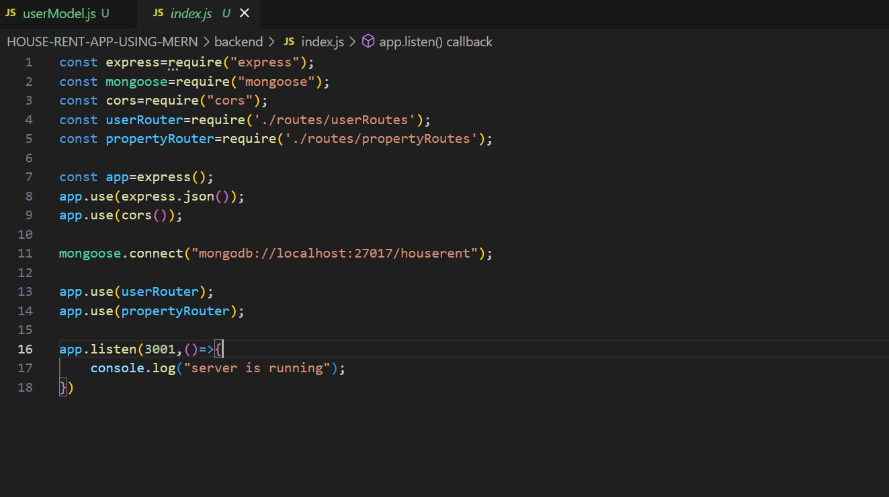

* The backend APIs interact with MongoDB using Mongoose ODM Key interactions include:
  + User Management:

**Register:**

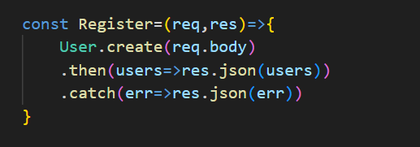

**Login:**

* + Property Management:

**PropertyDetails:**

**IndvidualDetails:**

**uploadProperty:**

